**PROGRAM PRACTICE ASSIGNMENT**

Name – Ashutosh Soni

Id – 2018ucp1505

**Question:** Employee Class) Create a class called Employee that includes three instance variables—a first name (type String), a last name (type String) and a monthly salary (double). Provide a constructor that initializes the three instance variables. Provide a set and a get method for each instance variable. If the monthly salary is not positive, do not set its value. Write a test app named EmployeeTest that demonstrates class Employee’s capabilities. Create two Employee objects and display each object’s yearly salary. Then give each Employee a 10% raise and display each Employee’s yearly salary again

**Answer:**

**Program for the same in Java:**

/*

Name: Ashutosh Soni

Id: 2018ucp1505

*/

import java.lang.String;

class Employee {

// Instance member variables

String firstName;

String lastName;

double monthlySalary;

// Default constructor

Employee () { }

// Overloaded constructer as required ...

Employee (String firstName, String lastName, double monthlySalary) {

this.firstName = firstName;

this.lastName = lastName;

this.monthlySalary = monthlySalary;

}

// Set Methods

void setFirstName (String firstName) {

this.firstName = firstName;

}

void setLastName (String lastName) {

this.lastName = lastName;

}

void setMonthlySalary (double monthlySalary) {

this.monthlySalary = monthlySalary;

}

// Get Methods

String getFirstName () {

return this.firstName;

}

String getLastName () {

return this.lastName;

}

double getMonthlySalary () {

return this.monthlySalary;

}

}

public class ProgramPracticeAssignment {

public static void main (String []args) {

Employee firstEmployee = new Employee("Ashutosh","Soni",50000.50);

Employee secondEmployee = new Employee ();

secondEmployee.setFirstName("Sailendra");

secondEmployee.setLastName("Sonkar");

secondEmployee.setMonthlySalary(45000.23);

// For first Employee

System.out.print("Yearly Salary of "+ firstEmployee.getFirstName() + " "+firstEmployee.getLastName()+" is : ");

System.out.println(12*(firstEmployee.getMonthlySalary()));

double newSalary = 1.1*12*firstEmployee.getMonthlySalary();

System.out.println("Yearly Salary after 10% hike becomes: "+ newSalary);

// For second Employee

System.out.print("Yearly Salary of "+ secondEmployee.getFirstName() + " "+ secondEmployee.getLastName() + " is: ");

System.out.println(12*(secondEmployee.getMonthlySalary()));

newSalary = 1.1*12*secondEmployee.getMonthlySalary();

System.out.println("Yearly Salary after 10% hike becomes : "+ newSalary);

}

}

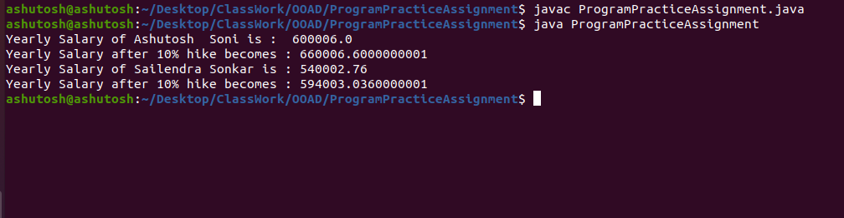**Output of the Program:**